Reef-PI PWM module information

Contents

1. Introduction 2

2. Combined Raspberry PI/HAT/PWM modules 3

3. PWM board: 4

2. Schematic: 5

3. Functional overview: 6

4. BOM: 6

5. Connectors: 8

5.1. I2C + 12V from HAT 6 pin connector: 8

6. PCA9685 address selection: 9

7. Assembly instructions 9

7.1. Start with PCA9685 controller. There are several methods here: 9

Positioning 10

With only a solder station 10

Hot air gun 10

Hot plate 10

Reflow oven 11

Solder Wick 11

3rd party assembly 11

Testing 11

7.2. Remaining through hole components 12

8. Assembled PWM module 13

9. Stacking 13

10. Debugging: 13

10.1. Check I2C address: 13

10.2. Verify the operation of port 0 directly from the PCA9685 14

10.3. Verify output of PWM Port 0 15

10.4. PWM module doesn’t work when connected to light controllers 15

11. Compatible light controllers 15

12. Challenges 15

12.1. Distance between PWM connectors 15

12.2. PCA9685 address selection on the bottom of the PCB 16

Figure 1: Combined Raspberry PI, Reef-PI HAT and Reef-PI PWM modules 3

Figure 2: Overview top PWM module 4

Figure 3: Overview bottom PWM module 4

Figure 4: PWM Schematics 5

Figure 5: Functional overview top PWM module 6

Figure 6: Functional overview bottom PWM module 6

Figure 7: I2C and power connector 8

Figure 8: PCA9685 address setting 9

Table 1: Revision history 2

Table 2: Things to do to this document 2

Table 3: BOM including footprints 7

Table 4:BOM including links to datasheets 8

Table 5: BOM including potential supplier link 8

Table 6: BOM including Manufacturing Part Number 8

Table 7: I2C and 12V connector 9

Table 8: PCA9685 address setting 10

Table 9: Shortcut checklist (optional) 12

Table 10: Proposed sequence to mount through hole components 13

|  |  |  |
| --- | --- | --- |
| Revision | Reason | Date |
| 1.0 | Original release for PWM 0.3 | 9 Nov 2018 |

Table : Revision history

Planned updates to this document:

|  |  |
| --- | --- |
|  | Planned addition or update |
| a) | Update photo’s of PWM module from v0.2 to v0.3 |
| b) | Picture of I2C connector to be added ! |
| c) | Verify C1 in assembly status in 7.2 (may be difficult after C2 and C3 are added) in PWM v0.3 |
| d) | Verify output voltages in 10.3 with final plug and no load |
| e) | Verify reflow oven with stencil (7.1, chapter reflow oven) |

Table : Things to do to this document

# Introduction

The Reef-PI_PWM module is designed to control up to 16 light controllers based on the NXP PCA9685 chip and can be controlled with the Reef-PI software running on a Raspberry PI (models 2 and 3). It’s designed to piggy back on top of the Reef-PI_HAT which fits directly on the Rasberry PI providing functions such as up to 16 VAC relays, temperature interface, 2 Auto Top Off and 2 12V motor control interfaces.

Technically The I2C address of the PCA9685 chip can be set on the PWM board, but presently Reef-PI only supports the standard address and most likely no more than 16 lights need to be controlled.

It’s possible to use the PWM module without the HAT but then separate wiring is required between the Raspberry PI GPIO ports (I2C interface), plus an additional 12V DC to the PWM module I2C interface.

The main challenge of this module is soldering the PCA9685 controller which is a TSSOP-28 SMD housing, but I think most people will be able to manage this with a good solder iron. Good advice for soldering SMD components can be found on Youtube.

It should be noted that only very small 2.5mm plugs can be used due to the small distance between the PWM connectors. (Present view is CUIinc MP-2511, https://www.mouser.at/ProductDetail/490-MP-2511).

# Combined Raspberry PI/HAT/PWM modules

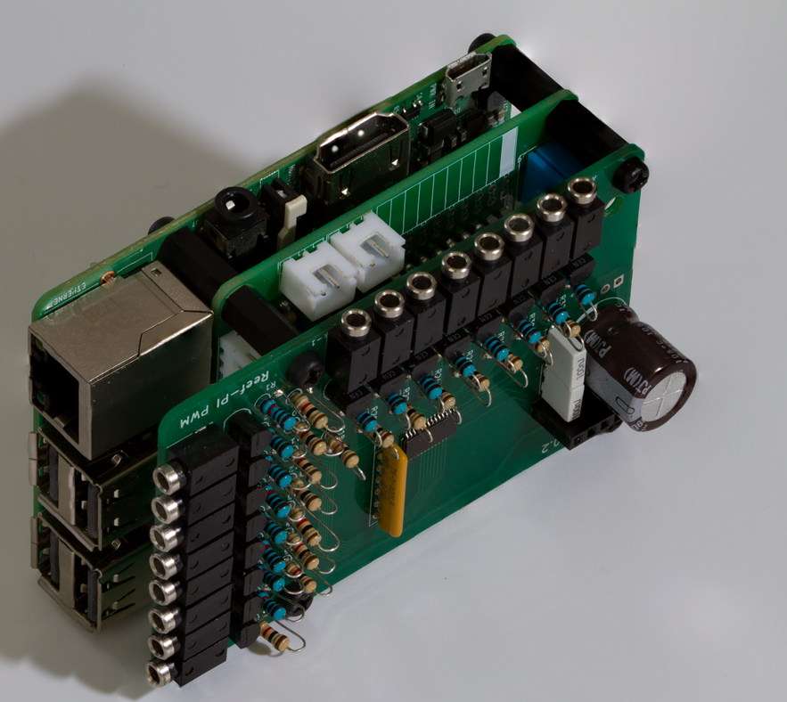

Figure : Combined Raspberry PI, Reef-PI HAT and Reef-PI PWM modules

This configuration provides following functions running Reef-PI software on the Raspberry:

16 digital outputs (for external relays board)  
2 ATO interfaces for optical sensors  
2 Dosing pump interfaces  
DS18B20 interface for multiple temperature sensors  
16 PWM interfaces for 0-10V light control

For more details on the Reef-PI_HAT module, refer to the Reef-PI HAT documentation.

# PWM board:

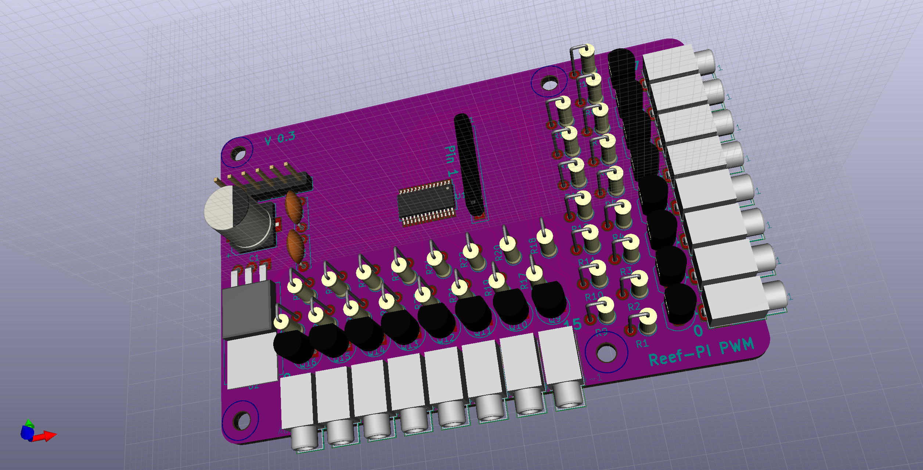

Figure : Overview top PWM module

The PWM module receives power via the upper left connector.

DO NOTE: The shown connector in this 3D model is wrong! Please refer to picture <x> for the correct connector. Also the PWM.csv file has the correct link, however the same connector can be found at much lower prices than the one shown in the BOM link.

For PWM port assignments see Functional overview:

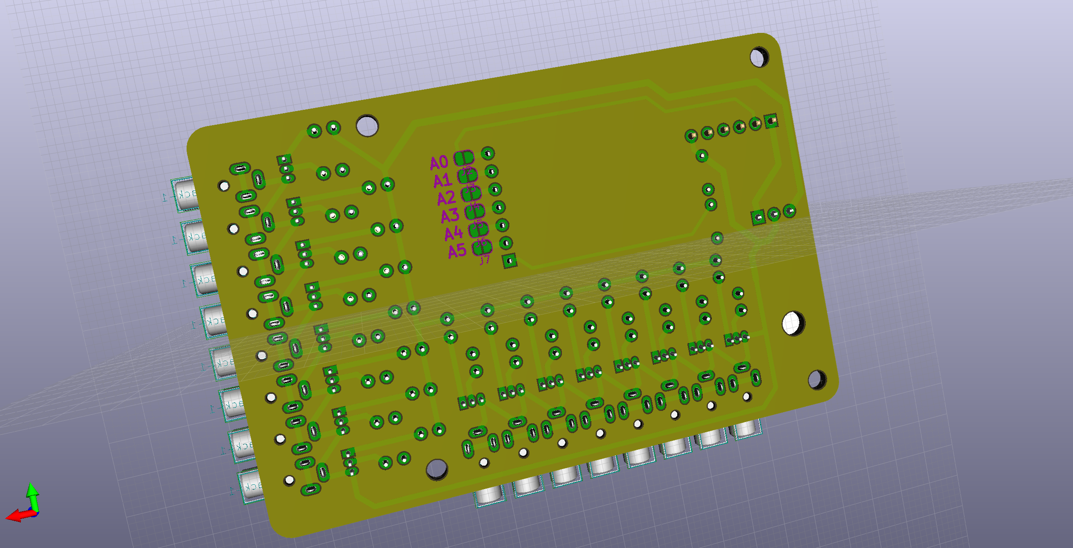

Figure : Overview bottom PWM module

Also here the shown connector on the upper right is wrong! These connectors are much longer to fit in the I2C interface of the Reef-PI HAT module.

The connections A0-A5 can be used to change the I2C address of the PCA9685 controller. Presently they have no use with the Reef-PI software, so do not change.



# Schematic:



Figure : PWM Schematics

# Functional overview:

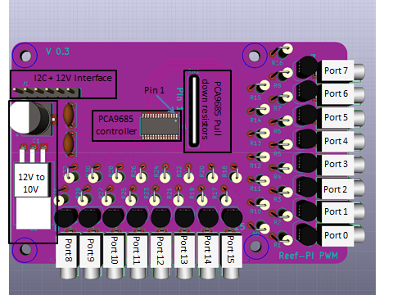

Figure : Functional overview top PWM module

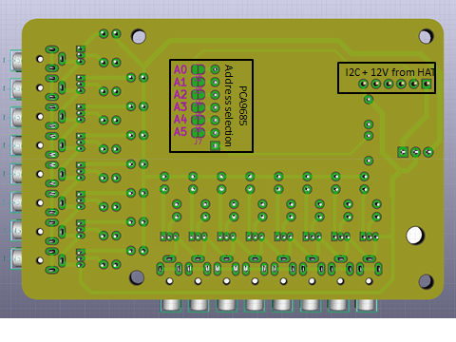

Figure : Functional overview bottom PWM module

# BOM:

Have a look at the PWM.CSV file to have all info in one file and you can copy links to datasheets and potential supplier there.



Table : BOM including footprints



Table : BOM including links to datasheets



Table : BOM including potential supplier link



Table : BOM including Manufacturing Part Number

# Connectors:

## I2C + 12V from HAT 6 pin connector:

This connector directly fits to the 6 pin header on the Reef-PI HAT. Pin 1 is the square solder hole on the bottom of the PCB (closest to side of the PCB).

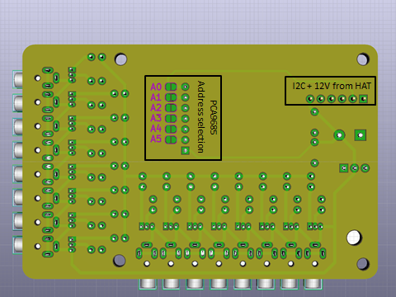

Figure : I2C and power connector

|  |  |
| --- | --- |
| Pin | Function |
| 1 | 12V |
| 2 | 5V |
| 3 | SDA |
| 4 | SCL |
| 5 | Not used |
| 6 | GND |

Table : I2C and 12V connector

# PCA9685 address selection:

Although it’s possible to change the I2C address of the PCA9685 on the PWM module, these contacts should be left open as Reef-PI will only supports its default address



Figure : PCA9685 address setting

|  |  |  |  |  |  |  |
| --- | --- | --- | --- | --- | --- | --- |
| A5 | A4 | A3 | A2 | A1 | A0 | Address |
| 0 | 0 | 0 | 0 | 0 | 0 | 0x40 |
| 0 | 0 | 0 | 0 | 0 | 1 | 0x41 |
| 0 | 0 | 0 | 0 | 1 | 0 | 0x42 |
| 0 | 0 | 0 | 0 | 1 | 1 | 0x43 |
| 0 | 0 | 0 | 1 | 0 | 0 | 0x44 |
| . | . | . | . | . | . | . |
| . | . | . | . | . | . | . |
| 1 | 1 | 1 | 1 | 1 | 0 | 0x7E |
| 1 | 1 | 1 | 1 | 1 | 1 | 0x7F |

Table : PCA9685 address setting

# Assembly instructions

## Start with PCA9685 controller. There are several methods here:

The PCA9865 is a TSSOP-28 SMD package with much smaller footprint distances than all other through hole components on the PWM module (in version 0.3 also the C1 capacitor is an SMD component but much bigger and its solder points the size of the through hole transistors solder pins. Reason to change to an SMD C1 component was related to height restrictions in order to allow other I2C boards to be added on top of the PWM module). Since it has the lowest height and requires precision soldering, it’s important to start with the PCA9685 component before any other!

This also has another advantage, if all goes wrong, you only loose the PCB and PCA9685 and none of the other components. Since PCB’s are normally ordered at quantities of 10 and relatively inexpensive this is the least of a problem. It may be advisable to order more PCA9685 to avoid waiting time and additional shipments costs if you’re unsure about soldering the PCA9685.

If unsure, have a look at some SMD soldering tutorials on Youtube to give you some better understanding.

### Positioning

The use of a good solder station and solder tip is important. This step is recommended for any other assembly solution of the PCA9685 component described below.

Simplest way is to first position the chip precisely on the PCB with just 1 solder point. Don’t try to force the chip to move or rotate with just 1 solder point cooled down as it will bend the pin. If the chip is not positioned precisely, heat up the pin again and then move to the required position. If the chip is positioned correctly (horizontal, vertical and rotation), solder the opposite pin. (So for instance start with pin 1, the pin 8 or first pin 7 then pin 14). Take your time for this activity, it’s the most crucial step of assembling the PWM module!

If you’re not sure about the exact location (e.g. eyes), take your time and use an amplifying glass or take a picture and verify that the chip is positioned correctly. I don’t have stable hands and have troubles looking very close (e.g. <15cm), this step I can do as well, just take your time!

### With only a solder station

I think most people can do it this way. After the PCA9685 has been positioned correctly, just solder each other pin. Don’t press from the side of the pins as they may bend. If for whatever reason you create a shortcut between 2 or more pins, don’t worry, see Solder Wick below. Nevertheless try to avoid bending pins

### Hot air gun

With this I’ve had the best result so far. I positioned the chip as described in Positioning, then placed solder paste over the other pins and used an solder hot air gun to solder all the remaining pins. Important here is the amount of solder paste (After I added the solder paste manually via syringe, I reduced it to around 50% by moving it around with a screw driver. For sure it has to remain below the top the TSSOP-28 housing). It doesn’t matter if the solder paste ‘shortcuts’ the pin, with the hot air gun it will reduce the solder paste in size and only solder the pins unless there is too much solder paste, then you’ll have to use the Solder Wick method as described below

An additional advantage of the hot air gun is that you can remove the TSSOP-28 if all goes wrong. Here it’s important to manage the temperature and it takes some time before the solder becomes fluid again. If a too high temperature is used the PCA9685 may get damaged.

### Hot plate

Some people prefer this method above a reflow oven, as they can move around components while the solder paste is fluid. However I think people who can do this, can also solder with just a solder iron for small PCBA (PCB Assembled) quantities. I have no experience with this method.

### Reflow oven

This is still a little trial and error for me. Basically the low cost reflow over is working fine, it’s the dosing of the solder paste for which I used a solder paste dispenser. There are 2 main issues for me of which I only solved 1 so far:

* When the solder paste comes out of the syringe it doesn’t stick to the PCB board (keeps hanging on the nozzle). When I add additional flux on the PCB, it works much better.
* The amount of solder paste is too much. This I don’t know yet how better to control.

When there is too much solder paste the PCA9685 starts to ‘float’ and doesn’t position itself correctly as it normally should do in a reflow oven. So the 2nd time I tried the reflow oven I used Positioning again and removed some solder paste supplied by the dispenser, it was better, but still not as good I was hoping for. Needed to use the Solder Wick solution again, but then it was ok for use.

Another alternative would be to use a stencil, I have 1 in place for the PCA9685 but have not yet tried this solution.

### Solder Wick

Solder wick is a solution to absorb solder with a finely braided wire with flux. With solder wick and a solder iron you can remove shortcuts between pins by placing the solder iron on the shortcut and heat it with the solder iron from above. It’s advisable to add some solder on the solder iron tip before placing it on the solder wick to improve heat transfer.

If all goes wrong see the 2nd paragraph in the section Hot air gun.

### 3rd party assembly

This could be an interesting solution when a larger quantity of boards would be required. PCBway for instance offers 50 pcs for 88USD.

### Testing

After all pins have been soldered and optically they look to be ok, it’s still recommended to test for potential shortcuts. This is not so difficult as expected when we don’t measure directly on the PCA9685 chip but on components/footprints the individual pins are connected to.

For instance to test a short cut between pin 1 and 2, you can measure between footprint A0 and A1 which are much bigger.

To perform this test, print out the schematics to see the connections between components and the top and bottom PCB lay-out and start measuring if no shortcuts exist or follow the table below. The PWM module may not be powered on for this test.

|  |  |  |  |  |
| --- | --- | --- | --- | --- |
| PCA9685 | | Testpoints | |  |
| Pin | Pin |  |  | OK |
| 1 | 2 | A0 (*1) | A1 (*1) | □ |
| 2 | 3 | A1 (*1) | A2 (*1) | □ |
| 3 | 4 | A2 (*1) | A3 (*1) | □ |
| 4 | 5 | A3 (*1) | A4 (*1) | □ |
| 5 | 6 | A4 (*1) | R1 (*2) | □ |
| 6 | 7 | R1 (*2) | R2 (*2) | □ |
| 7 | 8 | R2 (*2) | R3 (*2) | □ |
| 8 | 9 | R3 (*2) | R4 (*2) | □ |
| 9 | 10 | R4 (*2) | R5 (*2) | □ |
| 10 | 11 | R5 (*2) | R6 (*2) | □ |
| 11 | 12 | R6 (*2) | R7 (*2) | □ |
| 12 | 13 | R7 (*2) | R8 (*2) | □ |
| 13 | 14 | R8 (*2) | U2 middle pin | □ |
| 15 | 16 | R31 (*2) | R29 (*2) | □ |
| 16 | 17 | R29 (*2) | R27 (*2) | □ |
| 17 | 18 | R27 (*2) | R25 (*2) | □ |
| 18 | 19 | R25 (*2) | R23 (*2) | □ |
| 19 | 20 | R23 (*2) | R21 (*2) | □ |
| 20 | 21 | R21 (*2) | R19 (*2) | □ |
| 21 | 22 | R19 (*2) | R17 (*2) | □ |
| 22 | 23 | R17 (*2) | U2 middle pin | □ |
| 23 | 24 | U2 middle pin | A5 (*1) | □ |
| 24 | 25 | A5 (*1) | (*4) | □ |
| 25 | 26 | (*4) | J1 pin 4 | □ |
| 26 | 27 | J1 pin 4 | J1 pin 3 | □ |
| 27 | 28 | J1 Pin 3 | J1 pin 2 | □ |

Table : Shortcut checklist (optional)

(*1) – Testpoint is closest to RN1

(*2) – Testpoint is opposite to the round circle shown on the PCB for the

(*3) – Testpoint farthest away from RN1

(*4) – This connector of the PCA9685 is not connected, so can’t be tested elsewhere, except directly on pin 25 from the PCA9685.

Unfortunately we can’t test the PCA9685 electrically as it would require the long and high 6 pin stackable header to be installed which would make it difficult to mount the other through hole components at this stage. However if you want to test, you can solder some wires and connect them to +5V, GND, SCL and SDA on the Raspberry PI and remove them afterwards. See Check I2C address: below

## Remaining through hole components

Simplest way to continue is to use a sequence of component height on the PCB from low to high. In my view following sequence would be preferred:

|  |  |
| --- | --- |
| Step | Component(s) |
| 1 | U2 |
| 2 | RN1 |
| 3 | Q1 Q2 Q3 Q4 Q5 Q6 Q7 Q8 Q9 Q10 Q11 Q12 Q13 Q14 Q15 Q16 |
| 4 | J8 J9 J10 J11 J12 J13 J14 J15 J16 J17 J18 J19 J20 J21 J22 J23 |
| 5 | C2 C3 |
| 6 | R1 R2 R3 R4 R5 R6 R7 R8 R17 R19 R21 R23 R25 R27 R29 R31 |
| 7 | R9 R10 R11 R12 R13 R14 R15 R16 R18 R20 R22 R24 R26 R28 R30 R32 |
| 8 | C1 |
| 9 | J1 |

Table : Proposed sequence to mount through hole components

An alternative is to solder uA7810, C1, C2, C3 and one PWM channel (for instance R1, R9, Q1, J1 and J2) to verify if the basic module is working. Disadvantage of this is that will be more difficult to add the other components thereafter

# Assembled PWM module

# Stacking

# Debugging:

## Check I2C address:

First verify that the PCA chip is working and on the correct port. This can be done with i2cdetect. Logon to the Reef-PI Raspberry PI and open a shell or use SSH (my preference). On the console use I2Cdetect as shown below.

Required package: i2c-tools (sudo apt install i2c-tools)

Command line: i2cdetect –y 1

This should show a text written table:

0 1 2 3 4 5 6 7 8 9 a b c d e f

00: -- -- -- -- -- -- -- -- -- -- -- -- --

10: -- -- -- -- -- -- -- -- -- -- -- -- -- -- -- --

20: -- -- -- -- -- -- -- -- -- -- -- -- -- -- -- --

30: -- -- -- -- -- -- -- -- -- -- -- -- -- -- -- --

40: 40 -- -- -- -- -- -- -- -- -- -- -- -- -- -- --

50: -- -- -- -- -- -- -- -- -- -- -- -- -- -- -- --

60: -- -- -- -- -- -- -- -- -- -- -- -- -- -- -- --

70: 70 -- -- -- -- -- -- --

Port 40 is the required port, 70 is a generic port for the PCA9685

When ports 40 and 70 are not shown, the PCA9685 is not communicating with the Raspberry PI and HAT. Verify if 5V and GND are available (12V is not required for this) on the PWM module I2C connector as defined in I2C + 12V from HAT 6 pin connector:.

Power off and verify if no shortcuts exist between the PCA9685 pins (note: use the schematics and PCB layout so you measure on the through hole components.

<Open>Power off and verify with an ohm meter if connections exist between the Raspberry GPIO port 3 and PWM J1 pin 3. Also verify connection between Raspberry GPIO port 5 and PWM J1 pin 4

When a different port is shown then 40, there is something wrong with the PCA9685 address, verify the A0-A5 connections as listed in PCA9685 address selection: are open.

## Verify the operation of port 0 directly from the PCA9685

Go to the Reef-PI website on your Raspberry PI with a browser.

1. In the tab “configuration” go to “settings” and ensure that:
   1. PCA9685 is enabled
   2. pca9685_pwm_freq is set to 1500
   3. Press “update” at the bottom when changes are made
2. In the tab “configuration” go to “connectors”
   1. If unsure delete all entries under “Jacks”
   2. Create a new jack by pressing the green “+” under Jacks
   3. Ensure that you can select PCA9685 under “Driver”
   4. Enter “P0” in the “name” box
   5. Enter “0” in the “pins” box
   6. Press “Add” to add Jack P0
3. Then go to tab “lighting”
   1. Remove entries when unsure
   2. Press green “+”
   3. Enter “Port0” in the “Name” box
   4. Press down button after “Jack” and select “P0”
   5. Press “add”, now you should see a line with “P0” with an “Expand button behind it
   6. You will see “channel 1” with a “+” sign behind, press this “+” button
   7. Set “profile” to fixed and slider to 50% and press “save”
   8. Measure now between following points (Black is GND on heatsink, red is left pin of R1):
   9. You should measure a value close to 2.5V

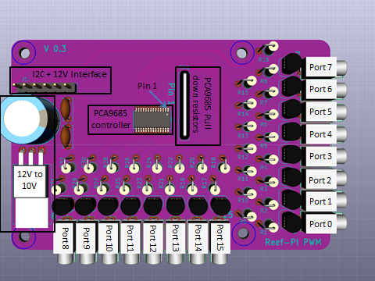

-

+

* 1. On the Reef-PI web page, press “edit” again, move slide to 99% (for whatever reason at 100% it reads 0V!) and press “save” again. Now you should have a value close to 5V
  2. Basically every % setting should show a multiple of 0.05V

In case the voltage doesn’t change between 0 and 100% of the slider, the PCA9685 is not sending the information to R1 (for whatever reason, maybe solder joints?)

If the voltage does change but not close to the values mentioned above there may be a problem with the transistor after R1 (Q1). Try to remove Q1 and verify measured values in ‘i’ and ‘j’ above again. If they now have a bigger difference, there is something wrong with Q1

## Verify output of PWM Port 0

Best is to test with a plug without load and repeat steps g-k in 10.2. Now the voltage should show around 10V at 0%, around 5V at 50% and almost 0V at 99%.

## PWM module doesn’t work when connected to light controllers

When all tests above are working properly, the PWM module should work as expected. However the module is only capable to supply a total of 1A of power to all the light controllers connected. Verify the power at the wire (as shown in the pictures) of R9, this should be 10V. If lower, then too much current may be required.

It should be noted that the 10V output is supplied over a 1K resistor, this means that with 100mA current drawn the output voltage will drop to 9V max. This doesn’t have an impact on the PWM signal itself.

If more power is required to the light controllers it’s possible to remove the uA7810 (LM7810) and supply an external, more powerful power supply to pins 2 (GND) and 3 (10V) to the solder points of the uA7810.

# Compatible light controllers

None tested so far

# Challenges

## Distance between PWM connectors

The distance between the individual PWM connectors is only 5.7mm which doesn’t fit most 2.5mm jacks. Present view is to use the CUIinc MP-2511 and use a 3D housing for this connector to avoid stress on the cabling (not made so far).

It’s no problem if the outer ring of the 2.5mm plug touch each other, they are all connected to GND on the PCBA.

Alternatively it would require a redesign of the PCB lay-out by moving the PCA9685 and 10V power supply to the top center and move some PWM connectors to the left side. The disadvantage of this is to have 3 sides with connectors which I would like to avoid.

## PCA9685 address selection on the bottom of the PCB

It’s required to disassemble the PWM module from the HAT in order to change the PCA9685 address. I don’t see this as a major concern for multiple reasons:

* Reef-PI presently doesn’t support multiple PCA9685 addresses
* Changing addresses is not a trial and error activity in an assembled working environment